Title Has Every Word Capitalized, Bold, Font Size 14: subtitle in lowercase
Title in Portuguese: same as the previous item, without bold, in italics
ABSTRACT  The title will be ABSTRACT, font Times New Roman, size 12, capital letters, bold. The abstract text will use Times New Roman font, size 10, justified paragraph alignment, with SINGLE line spacing. The text must not exceed the maximum number of 250 words. Use this space to write the abstract. | Author 1  Institution, place  Email:  ORCID:  Author 2  Institution, place  Email:  ORCID:  Author 3  Institution, place  Email:  ORCID:
Keywords: Keywords list. Use period to separate. First word capitalized. From three to five words.
RESUMO  The Editors will make an exact translation of the abstract into Portuguese in case the paper is accepted for publication. | DO NOT FILL IN  RAN  Revista Agulhas Negras  eISSN (online) 2595-1084  http://www.ebrevistas.eb.mil.br/aman    https://creativecommons.org/licenses/by/4.0
  Received: | 00 mm 20xx
  Reviewed: | mm 20xx
  Received after revised: | mm 20xx
  Accepted: | 00 mm 20xx
  
Palavras-chave: keywords. In Portuguese.

Introduction

The objective of this text is to provide authors with important information regarding the format and presentation standards for interviews submitted to RAN - Revista Agulhas Negras.
The paper should be divided into sections: Introduction, Body of the Interview (transcribed questions and answers) and References. Authors, however, are allowed to change the nomenclature of topics. Numbering must be sequential and in Arabic numerals.

Guidelines on Formatting

The titles of the main sections are Capitalized and in bold type. The body of the text is justified and there is an extra line between the Topic Name and its text. Subtopics, if any, must be numbered in levels and must not be written in bold.

Example
All subtopics titles are written in Times New Roman, size 12, but are not in bold. There is not an extra line between the subtopic and its text.

Page layout
This subsection contains some information regarding the page layout. The page size is A4, portrait orientation and the margins are as follows:
- Top: 2,0 cm;
- Bottom: 2,0 cm;
- Left: 2,0 cm;
- Right: 2,0 cm.
There is no need to format the page number or the information in the footer. In case of acceptance for publication, this information will be modified by the journal editors.

The Content of the Text

For the continuous development of subjects and/or ideas, and according to the suggestion in Item 1 of this template, the author is recommended to include the following in each item/topic:

3.1 Introduction
Presentation of the subject to be discussed and/or approached - the author should go through the general aspects and objectives of his work/research, leading the reader to understand (clearly) what he/she intends to develop/highlight throughout the interview. It is important to report/describe the scientific and/or professional contribution that the interview can provide and/or highlight.
Acronyms and abbreviations must be written in parentheses and preceded by their meaning when first used in the text.
Quotes “with up to three lines are part of the paragraph/text and appear between quotation marks” (Author, 2024, p. 3). The period, in these cases, appear after the indication of the person(s) cited. The author can also choose the following format: according to Author (2024, p. 3), “quotes with up to 3 lines are part of the paragraph/text and appear between quotation marks”.
Separate direct quotations that are more than three lines from the text by leaving a line space above and below the quote. These quotes should be single line spaced, font size 10, and should bring a 4-centimeter indentation. Here is an example:

Gone were the days when learning a single, standard version of the language was sufficient. Migration, multiculturalism and global economic integration daily intensified this process of change. The globalisation of communications and labour markets made language diversity an ever more critical local issue. (Kalantzis; Cope, 2008, p 197).

3.2 Conclusion
It is not mandatory to write a conclusion for interviews. However, if the author decides to do so, he/she is expected to present his/her conclusions in a way that he/she can relate them to the objectives and/or hypotheses of the interview, based on the answers of the interviewee. Also, it is recommended to mention if the objective was fully achieved (or not).

About Images, Figures and Tables

The indicative text in the first line (or column) of the table must be in bold. The Title must come above, with only the 1st letter of the word Table / Figure” capitalized. It is separated from its title by a colon.
The “Source” must come under the table/figure, just the 1st letter Capitalized and separated from its title by a colon. Font: Times News Roman, size 11. There must be a line space between the text of the paper and the Figure/Table and Source indications (above and below). If a Table occupies space on different pages, the header row must be repeated. Below is an example.

Table 9: how students prefer to learn
Activity |  | Percentage
Interaction with other students |  | 60%
Apps |  | 25
Lectures |  | 5%
Book exercises |  | 10%
Source: Barros Junior (2020)

For Images, the author is asked to use Arabic numerals to number them. The caption must come above the image, with only the first letter capitalized in the word “Image” followed by a colon. The image title or description must have the first letter in lowercase (with the exception of proper nouns).
The “Source” must come under the table/figure, just the 1st letter Capitalized and separated from its title by a colon. Font: Times News Roman, size 11. An example is below.

Image 1: armored vehicle weapons control
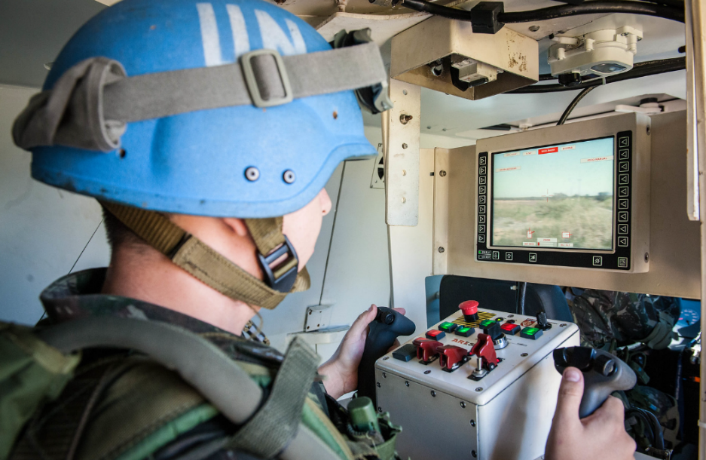
Source: Brazilian Army

There must be a line space between the text of the paper and the Image and Source indications (above and below).

Further Information

Regarding the use of foreign words, when necessary, they should appear in italics. If there is a need to include a quote in a foreign language, it must appear in a footnote, whereas its translation will appear in the text and will follow the rules mentioned in Section 2, plus the indication of the translation. The footnote must bear the title “Original text”. Example:

With our heart and mind focused on this objective of quality in publications, we ask the following question: what is research? Delimiting research in a single sentence becomes a research itself, and also a challenge. In general terms, research can be understood as the search for answers to pre-determined problems, i.e., the production of knowledge that uses already consolidated scientific procedures. (Freire Junior; Barros Junior; Bussolotti, 2021, p. vi, own translation).”

Footnotes must be numbered sequentially in Arabic numerals in the text and must appear at the end of each page, in the same order in which they appear in the text. The text of the footnotes must be justified, single spacing, font Arial, size 10.

References

The references list must start new page. The author must list all references cited in the paper, in alphabetical order of the author's SURNAME, following current ABNT standards (Brazilian Association of Technical Standards).
If a reference has a DOI number (Digital Object Identifier), it must be included.

* For authors who are not familiarized with the ABNT standard, we recommend that you write your references as close as possible to the examples below.

Examples:

a) Book with only one author:
LAST NAME, first/second name(s). Title in bold: subtitle, if any. Edition. Place of edition: Publisher, year of edition, number of pages.
b) Book with two authors:
LAST NAME, first/second name(s); LAST NAME, first/second name(s). Title in bold: subtitle, if any. Edition. Place of edition: Publisher, year of edition, number of pages.
c) Book with three authors:
LAST NAME, first/second name(s); LAST NAME, first/second name(s); LAST NAME, first/second name(s). Title in bold: subtitle, if any. Edition. Place of edition: Publisher, year of edition, number of pages.
d) Book with four or more authors:
LAST NAME, first/second name(s) et al. Title in bold: subtitle, if any. Edition. Place of edition: Publisher, year of edition, number of pages.
e) Chapter/Article in books:
LAST NAME, first/second name(s). Title of the article. In: LAST NAME, first/second name(s) (Ed./Org.). Título of the book in bold. Edition. Place: Publisher or Editorial Institution, year, the article initial page - the article final page. Available at: https://etc. or DOI number. Access: date (month, year).
f) Journals:
LAST NAME, first/second name(s). Title. Journal name, place, volume, number, pages, date in the format 01 jan. 2023. Available at: https://etc. or DOI number.
g) Thesis/Dissertation:
LAST NAME, first/second name(s). Title of the Thesis/Dissertation: subtitle if any. Year of conclusion. Number of pages. Thesis / Dissertation (Master’s / Doctor’s degree in specify the area) – Institution, place, year of publication. Available at: https://etc. or DOI number.
h) Newspaper article:
LAST NAME, first/second name(s). Title: subtitle if any. Newspaper. Place. Date, section, page(s).
i) online media:
LAST NAME, first/second name(s). Title: subtitle if any. Media name (website, online News etc), place, number, date (month, year). Available at: https://etc. or DOI number. Access: date (day. month, year).
j) Decrees / Ordinance / Law
JURISDICTION. Title, number and date. Menu. Details os the document (if any). Place, date. Available at: Available at: https://etc. or DOI number Access: date (day. month, year).
Example:
BRAZIL. Law N. 571, 26 September, 2000. It defines Military Sciences, establishes its scope and establishes the purpose of its study. Available at: http://www.esao.eb.mil.br/images/Arquivos/spg/legislacao/downloads/PORT_517_CMT_EB.pdf. Access: 25 Sep. 2025.

N.B.: No interview will be rejected for failure at following the ABNT format.

This example paper follows the standards pre-established by the RAN Editors. It is highly recommended to follow this template.
Original text: Com o coração e a mente voltados a esse objetivo de qualidade em publicações, colocamos a seguinte pergunta: o que é pesquisa? Delimitar a pesquisa em uma única frase já se torna uma pesquisa em si e, também, um desafio. Em linhas gerais, pesquisa se traduz na busca de respostas para problemas pré-determinados, i.e., a produção de conhecimentos que se vale do emprego de procedimentos científicos já consolidados.

